MEDORA

DEPI Graduation Project
Strategy & Documentation Blueprint
Project promise
Medora brings a patient’s medical documents and care tasks into one organized timeline, so patients can retrieve information and share selected records with authorized doctors more easily. AI supports organization and summarization; clinical decisions remain with qualified healthcare professionals.

1. Executive Summary
Medora is a proposed two-interface digital healthcare platform: a patient interface for storing and organizing medical records and care tasks, and a doctor interface for viewing the records that a patient has authorized. It brings lab reports, scans, diagnoses, prescriptions, medication schedules, appointments, and follow-ups into a structured medical journey. AI is used for administrative support such as document classification and draft summaries, with human review; it is not positioned as an autonomous diagnostic tool.
The underlying user problem is fragmentation: important medical information can sit in paper files, messaging apps, laboratory portals, hospital systems, email, and personal phones. The project hypothesis is that a patient-controlled, easy-to-use record timeline plus consent-based sharing and follow-up reminders can reduce the effort required to find relevant information during a consultation. This hypothesis must be validated through patient and clinician interviews before it is presented as a proven market fact.
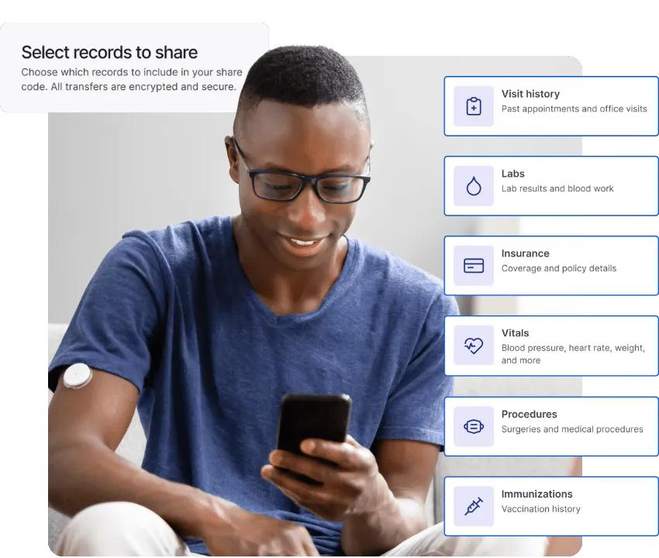

Recommended project positioning
Medora is the patient-first medical record organizer that helps people keep their health documents and follow-up tasks together, while giving doctors access only to the information patients authorize.

2. Project Definition and Scope
Element | Definition for Medora
Project name | Medora
Category | Digital health / patient-controlled medical record organization / care coordination support.
Project format | Team-based web-platform prototype with Patient and Doctor interfaces plus a marketing and automation system.
Problem statement | Patients can have medical information scattered across paper, messages, phones, labs, hospitals, and different doctors; finding the right record at the right time can be difficult.
Main objective | Improve the healthcare experience by organizing patient medical information and automating routine reminders and follow-up between patients and doctors.
Primary users | Patients/caregivers and doctors in the pilot segment; clinic staff may be included only if the team has capacity and a clear permission model.
Product principle | Patient-controlled sharing, explicit authorization, minimum necessary access, clear provenance, and human responsibility for clinical decisions.
Core scope | Profile; upload and categorize reports, scans, prescriptions; authorized doctor view; diagnosis/medication/appointment record; AI-assisted document organization; opt-in reminders.
Out of scope for the student MVP | Autonomous diagnosis, treatment recommendations, emergency triage, real clinical deployment, national EHR integrations, unreviewed medication changes, and processing live identifiable patient files.

Suggested product vision, mission, and slogan
Vision: A healthcare journey where important medical information can follow the patient safely and responsibly across care encounters.
Mission: Help patients organize, understand, and securely share the records and care tasks that support their conversations with healthcare professionals.
Slogan options: “Your medical story in one place”

User journey (future-state hypothesis)
Stage | Patient action | Medora support | Doctor benefit
Create | Create a profile and choose preferences. | Onboarding, consent disclosure, access settings. | Patient can be invited or connected only through a defined workflow.
Collect | Upload analysis, scan, prescription, or visit note. | Document type, date, source, and status labels; OCR/classification only where safe. | Records are easier to scan before or during a consultation.
Organize | Review the timeline and correct metadata. | Search, filters, draft summary, duplicate flag, missing-field indicator. | A quick view with sources and dates, not an AI-generated diagnosis.
Share | Authorize a specific doctor and scope/time window. | Permission grant, expiry/revocation, access log, secure view. | Access is limited to authorized records.
Follow up | Set reminders from a prescribed plan or appointment. | Consent-based reminders and completion tracking. | Better continuity and less manual reminder work; outcome requires validation.

3. Market Research and Validation Plan

4.1 What the public evidence currently supports
- Digital reach is plausible: DataReportal estimated 96.3 million internet users in Egypt in January 2025, equal to 81.9% of the population, and 116 million active cellular mobile connections. These are national digital-access indicators, not counts of patients who want or can use Medora
- Digital-health direction is aligned with recognized policy priorities: WHO’s Global Strategy on Digital Health 2020-2027 emphasizes the need to connect digital initiatives to robust strategy, while WHO’s digital-health guidance highlights interoperability, needs-led adoption, and equitable access
- Existing products demonstrate real competition: Egyptian/regional listings include doctor discovery, appointment booking, telehealth, clinic software, electronic records, and patient-facing medical profiles. Medora should not claim that electronic records or AI summaries are unique features.
- Privacy is a product requirement, not a later add-on: Egypt’s Law No. 151 of 2020 defines health-related data as sensitive personal data and contains consent, security, and other requirements. Executive regulation timing and exact obligations must be reviewed with qualified Egyptian counsel before any real-data deployment.

4.2 Core market problems we can test.
Hypothesis | How to validate | Evidence threshold to agree before presenting
Patients have trouble locating older reports at visits. | Interview 15-20 adult patients/caregivers and ask for a recent real journey without collecting their actual documents. | Repeated concrete examples, not just general agreement.
Doctors need relevant history before or during consultations. | Interview 8-12 doctors across 2-4 outpatient specialties; ask about current intake and record retrieval. | At least 5 interviewees describe a recurring workflow problem and a usable proposed solution.
Patients will upload and maintain their own records. | Clickable prototype test with 8-10 users; observe task completion and upload confidence. | Most testers can upload/categorize a synthetic record without help; document failures.
Clinics may pilot a patient-authorized record-sharing tool. | Interview 3-5 clinic owners/managers about workflow, liability, privacy, and integration objections. | At least 2 credible pilot-interest signals, with conditions written down.
Reminders and a timeline are more valuable than a document folder alone. | Concept test two prototype versions or ask respondents to rank benefits. | A clear leading use case that determines MVP priorities.
Arabic-first, mobile-responsive UX is important. | Test Arabic and English layouts, including right-to-left screens, on mobile devices. | Task success and comprehension data by language/device.

4.3 Research plan: primary, secondary, and product validation
Research activity | Sample / method | Questions answered | Output
Patient/caregiver interviews | 15-20 semi-structured interviews; recruit diverse ages and recurring-care experiences. | What gets lost? How are documents stored? What causes delay or frustration? What would create trust? | Pain-point themes, quotes with consent, journey map.
Doctor interviews | 8-12 clinicians from private outpatient settings; no patient-identifiable details. | What records matter before visits? What is the current intake? What could create unsafe reliance? | Clinical workflow needs, objections, access requirements.
Clinic stakeholder interviews | 3-5 clinic managers/owners or reception team members. | Who pays? What tools are used? What integration/security concerns exist? | B2B value drivers and buying criteria.
Survey | Target 50-100 respondents if feasible; transparent convenience sampling. | Record fragmentation frequency, preferred features, trust concerns, willingness to try. | Descriptive results, not a nationally representative estimate.
Competitor desk audit | Review the public pages in Section 6 and, where possible, product demos/trials. | Which workflows are strong or absent? How are prices and promises framed? | Feature/positioning matrix, dated with access notes.
Prototype usability tests | 8-10 test users on a synthetic patient journey. | Can users upload, label, share, revoke, and understand summaries? | Task-completion, error list, improvement backlog.

4.4 Interview guide for smart market research.

- متي أخر مرة طلب منك الطبيب تقريرا عن حالتك ولم تجده كيف حللت المشكلة؟
- أين تحتفظ حاليًا بمستنداتك الطبية؟ وما الجزء الأصعب في الوصول إليه أو فهمه؟
- ما المستندات أو المعلومات التي تحرص عادةً على إحضارها معك عند زيارة الطبيب؟ وما الأشياء التي قد تنساها أو لا تكون متوفرة أحيانًا؟
- .ما مدى ارتياحك لمشاركة سجلاتك الطبية إلكترونيًا مع الطبيب؟ وما أنواع صلاحيات التحكم في الوصول التي تتوقع توفرها؟
. أي من المميزات التالية سيكون الأكثر فائدة لك؟ ولماذا؟
- تنظيم المستندات الطبية.
- عرض السجلات في تسلسل زمني (Timeline).
- رابط لمشاركة السجلات مع الطبيب.
- تذكيرات بمواعيد الأدوية والزيارات الطبية.
- ملخصات للمستندات الطبية يتم إنشاؤها باستخدام الذكاء الاصطناعي.

. 5- ما العوامل التي قد تجعلك لا تثق في هذه المنصة أو تتجنب استخدامها؟
بالنسبة للأطباء: ما البيانات الموجودة في السجل الطبي التي يجب أن يظهر معها دائمًا المصدر الأصلي وتاريخ المستند؟ وما المعلومات التي يجب ألا يتم تلخيصها دون مراجعة بشرية؟
6- ما العوامل التي تجعل تجربة المنصة داخل إحدى العيادات أمرًا ممكنًا؟
- سهولة دمجها في سير العمل اليومي.
- توفير الوقت.
- تحسين تجربة المريض.
- التكامل مع الأنظمة المستخدمة حاليًا.
- التكلفة.
- ضمانات الخصوصية وحماية البيانات.

4.5 Market sizing: bottom-up, not invented
Do not take Egypt’s internet population as Medora’s total addressable market. Establish the first payer and pricing model, then calculate using verified counts.
Metric | Recommended calculation | Data required
TAM (Total Addressable Market) clinic subscription model | All potentially eligible clinics in the target country/geography x assumed annual subscription per clinic. | Reliable clinic counts by location and specialty; pricing interviews; existing system penetration.
SAM (Serviceable Available Market) - initial serviceable market | Clinics in Cairo/Giza and selected specialties that meet workflow, connectivity, and pilot-readiness conditions x annual plan value. | Geography/specialty breakdown; qualification criteria; clinic interviews.
SOM (Serviceable obtainable Market)- first 12 months | Realistic number of clinics the team can onboard x annual recurring revenue per clinic, with activation/churn assumptions. | Pilot capacity, funnel conversion, onboarding time, willingness to pay.
Patient reach (secondary adoption metric) | Active patient profiles per activated clinic, deduplicated where possible. | Pilot clinic volume; consented adoption and monthly active use.

4. Audience Segments and Personas

4.1 Segmentation
Segment | Need state | Priority | Message angle
Patients with recurring care needs | Multiple visits, analyses, prescriptions, or ongoing follow-ups. | High for pilot research | Keep the history and care tasks organized between visits.
Family caregivers | Coordinate records and appointments for a dependent or older relative. | High / test separately | A clearer overview for authorized family support, with explicit permissions.
Busy adults with occasional care | Want records easily available when needed. | Medium | Be prepared for the next consultation.
Independent doctors / small clinics | Need relevant patient history, organized files, and practical follow-up workflows. | High for B2B pilot | Get patient-authorized information in a concise, dated view.
Labs / diagnostic centers | Patients return with past tests; possible future sharing partners. | Future partner segment | A longer-term continuity use case; not necessary for MVP.

4.2 Persona A - recurring-care patient


Mohamed Alkashef - Senior Software Engineer - Netways | XING
Name: Mahmoud Ali (محمود علي)
B2C – Patient
Age: 38 years
Location: 6th of October City, Giza, Egypt
Occupation: Accountant in a private company
Family Status: Married, with one child
Category | Details
Background | An Egyptian working man who balances his job and family responsibilities and needs to manage his healthcare records.
Income Level | Middle-income household (illustrative).
Healthcare Behavior | Visits private doctors when needed, conducts periodic medical tests, and sometimes visits different specialists.
Current Tools | WhatsApp, smartphone gallery, paper medical reports, laboratory applications, and email.
Main Goals | Keep his medical records organized, access previous analyses quickly, and manage appointments and follow-ups.
Pain Points | Frequently forgets where he saved medical reports, loses printed prescriptions, and struggles to remember previous test results when visiting a new doctor.
Needs | Easy document uploads, a searchable medical timeline, appointment reminders, medication schedules, and secure record sharing.
Digital Behavior | Uses Facebook and WhatsApp daily, watches YouTube, searches Google for health information, and prefers mobile applications that save time.
Motivation | Avoid wasting time searching for medical documents, maintain better control over his health information, and simplify doctor visits.
Barriers / Objections | Questions whether the platform is secure, whether it is easy to use, and whether doctors will accept digital medical records.
Preferred Channels | Facebook, YouTube, Google Search, Instagram, and WhatsApp.
Adoption Trigger | Needs previous analyses or prescriptions during a consultation with a new doctor.
Medora Solution | A centralized medical record timeline that helps him organize his documents and share selected records with authorized doctors.

4.3 Persona B - independent doctor / small clinic.


Persona B – Egyptian Doctor
CliniDo | Book with the best doctors in Clinics Egypt Medical Clinic
Name: Dr. Ahmed Mahmoud
B2B – Healthcare Professional
Age: 43 years
Location: Dokki, Giza, Egypt
Occupation: Internal Medicine Specialist / Private Clinic Owner
Experience: 15 years
Category | Details
Background | An Egyptian doctor working in a private clinic who sees multiple patients daily and manages their follow-ups.
Income Level | Professional / Middle-to-upper income (illustrative).
Healthcare Environment | Works with private laboratories, hospitals, pharmacies, and other medical specialists.
Current Tools | WhatsApp, phone calls, paper patient files, printed analyses, and possibly clinic-management software.
Main Goals | Review relevant patient history, access previous analyses, improve consultation preparation, and organize patient follow-ups.
Pain Points | Patients forget previous reports, send incomplete information through WhatsApp, bring paper documents from different providers, and sometimes cannot remember medication history.
Needs | Organized patient records, easy access to patient-authorized documents, clear dates and categories, and reliable document viewing.
Digital Behavior | Uses WhatsApp extensively for professional communication, searches Google, uses Facebook, and may use medical platforms and digital clinic tools.
Motivation | Save time during consultations and make relevant patient information easier to review.
Barriers / Objections | Patient confidentiality, data accuracy, time required to learn another platform, additional administrative workload, and integration with existing clinic processes.
Preferred Channels | Facebook, WhatsApp, medical associations, professional referrals, and medical conferences.
Adoption Trigger | A patient arrives with organized previous medical records and shares them through Medora.
Medora Solution | A structured view of medical records that patients have explicitly authorized the doctor to access.

5. Competitors Analysis

Product / category | Publicly described focus | What it means for Medora | Limit / validation need
SehaFile (Egypt) | Describes a citizen-owned digital health profile, medical records, appointments, notifications, and clinic management [5]. | Very close to the patient-controlled record proposition; compare onboarding, cross-provider continuity, and permissions carefully. | Verify working product depth, integrations, pricing, active adoption, and user experience through a demo/interview.
DIME (Egypt) | Describes HIS, EMR/EHR, health-information exchange, connected providers, and a clinical-memory layer with AI [6]. | Directly overlaps the unified record and AI narrative; Medora must be sharply scoped and prove usability rather than claim category uniqueness. | The website is a vendor description; confirm current release, integrations, security certifications and target buyer.
TabeebPlus (Egypt/MENA) | Describes clinic EHR, patient records, appointment scheduling, prescription features, and file management [7]. | Relevant clinic-side competitor/alternative. The patient-owned multi-provider journey can be a differentiation hypothesis, not a guaranteed gap. | Confirm how patient-facing portals and external record sharing actually work.
CliniVisor (Egypt) | Clinic/medical-center management, comprehensive patient records, document uploads, investigation portals, e-prescription and workflow functions [8]. | Shows that doctor-side record and admin workflows are established expectations. | Explore whether its product focuses on a single clinic rather than a cross-provider patient timeline.
Medical Horus (Egypt) | Describes clinic management plus patient search/booking and keeping medical history for patients/families [9]. | Competes across clinic workflows and patient-facing record features; reinforces need for a narrow, verifiable advantage. | Check available modules, customer base, pricing, record-sharing controls, and actual AI behavior.
Vezeeta (Egypt / MENA) | Doctor discovery, appointment booking, telehealth, home visits and pharmacy-related services [10]. | Strong adjacent benchmark for patient acquisition and appointment discovery; not identical to a portable longitudinal record platform. | Compare its current patient-record, storage, reminder and provider-sharing functionality in a hands-on review.

6.1 Competitive positioning map (qualitative)

Position area | Examples to investigate | Implication
Strong booking / marketplace, not primarily portable records | Vezeeta as publicly described. | Benchmark reach, trust cues, discovery UX, and appointment conversion.
Strong provider-side workflow and clinic operations | TabeebPlus, CliniVisor, Medical Horus; DIME presents a broader clinical-memory/health-exchange claim. | Do not compete on clinic functions the student team cannot build robustly; integrate conceptually or target the patient journey first.
Patient record aggregation / health portal concept | SehaFile, MyChart, Apple Health Records in their respective markets. | Focus competitor analysis on patient control, provenance, ease of upload, authorized share, and local bilingual experience.

6.2 SWOT of Medora
Strengths | Weaknesses
Patient-first story; two-interface workflow; multiple record types; reminders; useful AI admin support; strong fit for a demonstrable DEPI automation project. | Early-stage trust; no verified integrations; no validated product-market fit; limited development time; data quality and AI errors are serious risks.

Opportunities | Threats
Private clinic pilots; Arabic-first and mobile-friendly UX; partnerships with clinics/labs; patient education content; a transparent consent and provenance experience. | Existing local record/clinic platforms; user reluctance to upload health data; cybersecurity incidents; regulatory obligations; adoption friction; interoperability complexity.

6. Value Proposition and Positioning

7.1 Value proposition statement
Proposed positioning statement
For patients and caregivers who struggle to keep medical information organized across different care encounters, Medora is a patient-first medical record organizer that brings documents, dates, and follow-up tasks into one timeline and Enables controlled sharing with authorized doctors. Unlike a folder of disconnected files, the intended experience adds structured metadata, visible source information, consent-based access, and AI-assisted organization with human verification.

7.2 Value proposition canvas
Customer profile | Value map
Jobs: locate records before a visit; recall dates and medications; prepare questions; share the right documents; manage appointments. | Products/services: secure record timeline, document tags, doctor-authorized view, reminder settings, AI draft summaries with links to source documents.
Pains: scattered records; missing dates; repeated explanations; upload friction; privacy anxiety; uncertainty about AI accuracy. | Pain relievers: one timeline, date/source labels, simple import, granular permissions, revocation/expiry, visible AI disclaimer and human review.
Gains: feeling prepared; reduced searching; easier handoff; continuity across visits; fewer forgotten appointments. | Gain creators: quick search, shareable authorized view, task reminders, Arabic/English UX, patient-controlled access history.

7.3 Message hierarchy
Layer | Message | Proof required
Core promise | Keep your medical journey organized in one place. | Prototype showing records by date/type/source.
Control | You choose what to share and with whom. | Permission design, consent flow, expiry/revoke and audit-log demo.
Clarity | Find reports and visit information more easily. | Usability test: time/task completion compared with current method.
AI support | AI helps organize documents and draft summaries; people verify them. | Test set showing extraction quality, failure handling and review state.
Continuity | Keep appointment and medication reminders alongside relevant records. | Demonstrable reminder logic based on user-confirmed or clinician-entered information.

7.4 Brand personality
Trustworthy, calm, clear, human, respectful, accessible, and non-alarmist. Avoid fear-based health messaging, exaggerated AI claims, confusing clinical jargon, and promises that the platform prevents disease or guarantees better outcomes.

7. Business Model and Strategic Review

8.1 Business Model Canvas and Revenue streams.
Canvas block | Medora hypothesis
Customer segments | Initial: private outpatient clinics and adult patients/caregivers who manage repeat visits. Later: multi-branch clinics, diagnostic centers, hospital groups, payer/provider partnerships, subject to evidence.
Value propositions | Patient-controlled medical document organization, authorized sharing, visible record provenance, reminders, and AI-assisted administrative organization.
Channels | Clinic pilot referrals; clinician/clinic partnerships; educational social content; search; community/health education partnerships; landing-page lead capture.
Customer relationships | Self-service patient onboarding, clear help content, human support for clinic pilots, opt-in notification settings.
Revenue streams | Test B2B clinic subscription or clinic-paid pilot first; consider optional patient premium only after validating willingness to pay. No sale of personal health data.

8. Marketing Strategy and Funnel

9.1 Strategic objective
Demonstrate that Medora addresses a credible information-organization problem and attract a small group of patients and clinic professionals to test a prototype. The capstone goal is learning and a working demonstration, not claiming nationwide adoption or clinical outcomes.

9.2 SMART learning goals for the capstone (planning targets)
Goal | Provisional target | Measurement note
Demand validation | 15-20 patient/caregiver interviews and 8-12 doctor interviews | Quality and diversity matter more than survey volume; record recruitment bias.
Clinic interest | 3-5 clinic stakeholder interviews; seek 2 credible pilot-interest signals | An interest signal is not a signed customer or a sale.
Prototype usability | 8-10 synthetic-data tests with task-level success tracked | Document failures and revisions; do not cherry-pick only successful tests.
Marketing funnel | Generate 30-50 relevant landing-page sessions per small test source where feasible and track every step | Targets depend on media access and project time. Report actual numbers, including zeros.
Lead handling | At least 95% of test form submissions correctly recorded in the CRM in a controlled test set | Use 10-20 synthetic submissions; this is a reliability target for the prototype.
AI document organization | Evaluate 20-30 synthetic sample documents across document types | Report field-level accuracy and errors; do not call this clinical accuracy.

9.3 STP - Segmentation, Targeting, Positioning
- Segmentation: recurring-care patients, caregivers, occasional-care patients, independent doctors/small clinics, and future provider partners.
- Initial target: independent/private outpatient clinics and the patients they serve in Cairo/Giza, with a focus on recurring visits where multiple documents are likely. Confirm selection after interviews.
- Positioning: patient-first organization and permission-based sharing - not another doctor marketplace, not an autonomous diagnostic tool, and not an EHR replacement in the first MVP.

9.4 Funnel stages
Stage | Audience question | Content / asset | CTA | KPI
Awareness | Why are my records hard to find? | Educational short videos, carousel, problem story. | See how Medora works. | Reach, video views, engaged sessions.
Consideration | Can I trust it and will it be easy? | Product walkthrough, privacy design explainer, FAQ, prototype demo. | Explore the demo / join the pilot list. | Landing-page engagement, CTA click rate, FAQ views.
Conversion | How do I try it? | Simple patient waitlist or clinic pilot form. | Request pilot access / book a clinic demo. | Form completion, qualified leads, booked demos.
Activation | Can I complete the first task? | Welcome flow, synthetic/sample-record tour, quick-start guide. | Create a record / invite an authorized doctor in prototype. | Activation rate, task success, time to first value.
Retention | Is it useful between visits? | Opt-in reminders, follow-up checklist, new feature education. | Return to timeline / confirm next task. | Weekly active users, repeat action rate, opt-out rate.
Advocacy | Would I recommend it? | Feedback request after the test; no manufactured testimonials. | Share feedback / refer a clinic pilot. | Satisfaction feedback, referral interest, qualitative themes.

9.5 Channel roles
Channel | Role | Content / action
Facebook / Instagram | Patient education and broad prototype awareness. | Short videos, carousels, myth-vs-fact about record organization, demo clips; avoid sensitive targeting and fear appeals.
Google Search | Capture active intent around digital medical records/clinic record tools if keyword volume and budget justify it. | Small exact/phrase keyword test, honest landing page, negative keywords for medical advice/emergencies.
Clinic partnerships | Highest-context route to pilot learning. | Direct outreach, one-page pilot brief, short demo, interview request.
Email / WhatsApp simulation | Opt-in follow-up and demo coordination. | Confirmation, scheduling, reminders, feedback request; no medical record data in marketing messages.

9. Content and Creative System

10.1 Brand voice rules
Do | Avoid
Use calm, plain language; show product screens; explain what AI does and does not do; describe consent clearly; use inclusive Arabic/English examples. | Fear-based illness scenarios; unsupported claims of better health outcomes; “100% secure”; “AI doctor”; fake patient stories; implying the platform replaces clinicians.

10.2 Content pillars
Pillar | Purpose | Example topics
Organize your medical journey | Problem awareness | What to bring to a visit; how to label reports; why dates and sources matter.
Patient control and privacy | Trust | What sharing permissions mean; how access can be limited/revoked in the prototype; privacy-by-design principles.
Prepared consultations | Education | Create a visit checklist; questions to ask; bring original reports and let the clinician interpret them.
Behind the product | Consideration | Prototype walkthrough; how document categorization works; how humans review AI summaries.
Clinic workflow learning | B2B credibility | Clinic interview insights (with permission); mock workflow; pilot onboarding and lessons.
Progress and feedback | Retention/community | Feature demos, user testing improvements, invitations to usability sessions.

10.4 30-day content calendar

اليوم | نوع المحتوى | القناة التسويقية | هدف مسار التحويل | فكرة المحتوى | الدعوة لاتخاذ إجراء (CTA)
1 | منشور كاروسيل | فيسبوك / إنستجرام | التوعية بالمشكلة | 5 أسباب تجعل العثور على الملفات الطبية أمرًا صعبًا | احفظ قائمة التحقق
2 | فيديو قصير | Instagram Reels / Facebook | التوعية | لحظة البحث عن تقرير طبي قديم: «هو التقرير ده فين؟» | شاهد النموذج الأولي
4 | استطلاع عبر القصص | Instagram | البحث والتحقق | ما نوع السجل الطبي الذي تجد صعوبة في العثور عليه؟ | صوّت وشاركنا رأيك
5 | منشور كاروسيل | فيسبوك / إنستجرام | التثقيف | قائمة بسيطة لتسمية الملفات الطبية: التاريخ، المصدر، النوع | احفظ المنشور أو شاركه
6 | فيديو قصير | Instagram Reels | التثقيف بالمنتج | كيفية رفع تقرير تحليل معملي تجريبي إلى الجدول الزمني في Medora | انضم إلى اختبار النموذج الأولي
7 | ملخص أسبوعي | جميع القنوات | التفاعل | ماذا تعلمنا من أبحاثنا الأولية؟ (اعرض النتائج الفعلية فقط) | اكتب مشكلة واجهتك في تعليق
8 | منشور كاروسيل | فيسبوك / إنستجرام | بناء الثقة | ماذا تعني مشاركة السجلات الطبية تحت تحكم المريض؟ | شاهد شرح صلاحيات الوصول
10 | تصميم للأسئلة الشائعة | فيسبوك / إنستجرام | معالجة الاعتراضات | هل تقوم Medora بتشخيص الأمراض؟ لا، بل تنظم السجلات والمهام الصحية | اقرأ الأسئلة الشائعة
11 | فيديو قصير | Instagram Reels | التثقيف | كيف تستعد لزيارة الطبيب من خلال تنظيم سجلاتك الطبية؟ | احفظ قائمة التحقق أو شاركها
13 | أسئلة وأجوبة عبر القصص | Instagram | البحث والتحقق | اسألنا عن النموذج الأولي والخصوصية وحدود إمكانيات المنصة | أرسل سؤالك
14 | منشور كاروسيل | فيسبوك / إنستجرام | التفكير في الحل | من ملفات طبية متفرقة إلى جدول زمني منظم حسب التاريخ | استكشف العرض التجريبي
15 | مقطع عرض توضيحي | جميع القنوات | التحويل | واجهة المريض: إضافة سجل طبي تجريبي وتصنيفه والبحث عنه | انضم إلى قائمة المهتمين بالتجربة
17 | منشور كاروسيل | فيسبوك / إنستجرام | التثقيف | ما الذي يجب التأكد منه قبل الاعتماد على تذكير متعلق بالأدوية؟ | احفظ قائمة التحقق
18 | فيديو قصير | Instagram Reels | الشفافية في استخدام الذكاء الاصطناعي | مقارنة بين ملخص أولي أنشأه الذكاء الاصطناعي والمستند الأصلي، مع التأكيد على ضرورة المراجعة والتحقق | شارك في اختبار سهولة الاستخدام
20 | أسئلة شائعة / قصص | Instagram | بناء الثقة | من يمكنه الاطلاع على السجل الطبي داخل النموذج الأولي لمنصة Medora؟ | راجع تصميم صلاحيات الوصول
21 | منشور أسبوعي عن التعلم | جميع القنوات | الشفافية | أهم 3 مشكلات ظهرت أثناء اختبارات سهولة الاستخدام، وما التغييرات التي أجريناها (اعرض النتائج الفعلية فقط) | تابع تحديثات تطوير المنتج
22 | منشور كاروسيل | فيسبوك / إنستجرام | التثقيف بهدف الاحتفاظ بالمستخدم | قائمة تحقق لمساعدة المريض على الاستعداد قبل زيارة الطبيب | احفظ قائمة التحقق
24 | فيديو قصير | Instagram Reels | التثقيف بالخصائص | كيفية العثور على سجل طبي باستخدام التاريخ أو النوع أو المصدر | استكشف النموذج الأولي
25 | منشور استطلاع | Facebook | البحث والتحقق | أي ميزة تمثل القيمة الأكبر بالنسبة لك: الجدول الزمني، أم مشاركة السجلات، أم التذكيرات، أم البحث؟ | أكمل الاستبيان في دقيقتين
26 | محتوى توضيحي عن الخصوصية | جميع القنوات | بناء الثقة | لماذا يجب ألا يخزن نظام إدارة العملاء التسويقي المستندات الطبية؟ | اقرأ مبادئ الخصوصية
27 | منشور كاروسيل | فيسبوك / إنستجرام | معالجة الاعتراضات | ما الوظائف التي لن تقدمها Medora في الإصدار الأولي؟ | اطلع على نطاق المشروع والأسئلة الشائعة
28 | دعوة لحضور عرض تجريبي | / جميع القنوات | التحويل | دعوة المستخدمين للمشاركة في اختبار سهولة الاستخدام باستخدام بيانات تجريبية | سجّل اهتمامك بالمشاركة
30 | ملخص الشهر | جميع القنوات | التفاعل والتوصية | ما الذي نجح؟ وما الذي لم ينجح؟ وما أولويات الاختبارات القادمة؟ | انضم إلى الاختبار القادم

10.5 Two short-form video scripts.
رقم | عنوان الفيديو | Hook – البداية الجاذبة | Message – الرسالة الرئيسية | Disclaimer / Qualification – التوضيح | Visual – العناصر البصرية | CTA – الدعوة لاتخاذ إجراء | المدة
1 | التقرير المفقود (The Missing Report) | «الطبيب بيسألك عن آخر تحليل عملته... يا ترى موجود على واتساب، ولا في معرض الصور، ولا وسط ملفات ورقية؟» | «Medora نموذج أولي لتنظيم التقارير الطبية حسب التاريخ والنوع والمصدر، علشان تقدر توصل لها بسهولة أكبر.» | «Medora بتنظم الملفات، لكنها لا تفسّر نتائج التحاليل بدلًا من الطبيب.» | لقطات سريعة لملفات ورقية، وملفات على الهاتف، ثم عرض جدول زمني تجريبي داخل Medora. | «انضم إلى اختبار سهولة الاستخدام.» | 20–35 ثانية
2 | شارك سجلاتك بشروطك (Share on Your Terms) | «ممكن الطبيب يحتاج يشوف تقريرك الطبي، لكن هل معنى كده إن كل شخص من حقه يشوف كل ملفاتك؟» | «تصميم Medora قائم على مشاركة السجلات بموافقة المريض، مع توضيح نطاق الصلاحيات وإمكانية إلغائها.» | «إحنا حاليًا بنختبر نموذجًا أوليًا، وأي استخدام فعلي للبيانات الطبية يتطلب مراجعة رسمية للخصوصية والأمان.» | تسجيل الشاشة أثناء عرض نموذج تجريبي للوحة صلاحيات مشاركة الملفات. | «شاركنا رأيك: إيه الصلاحيات اللي تتوقع تكون متاحة عند مشاركة سجلاتك الطبية؟» | 20–35 ثانية
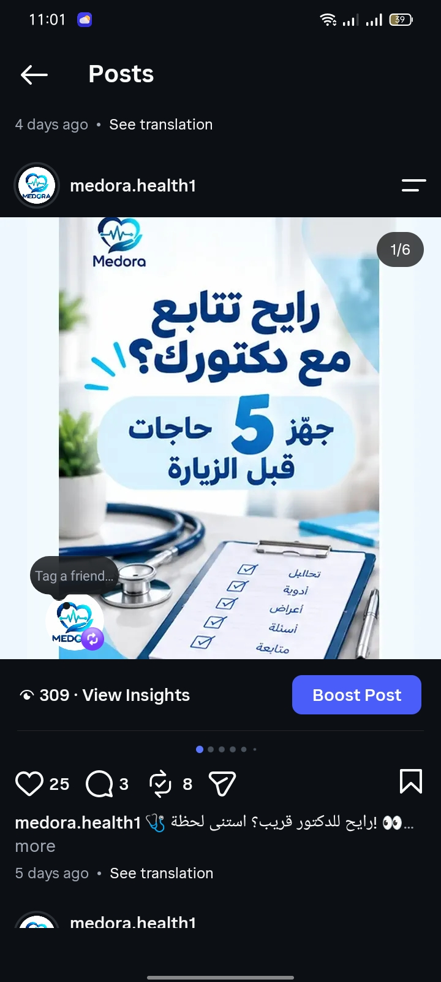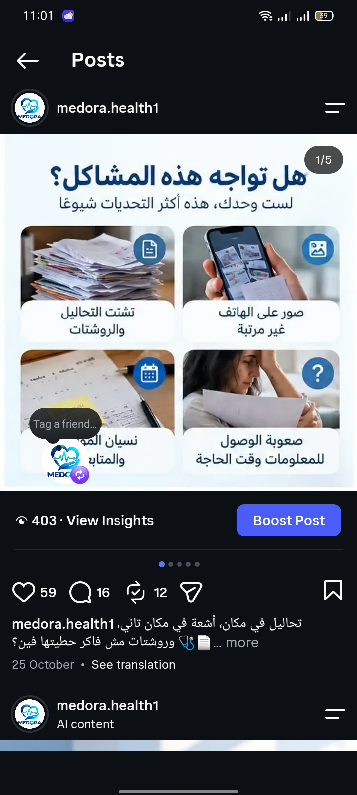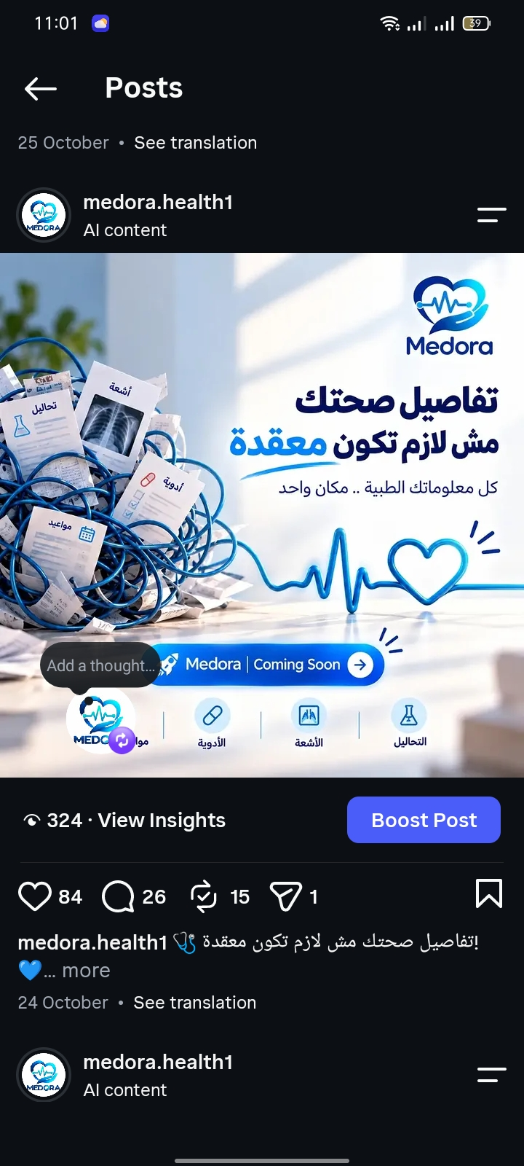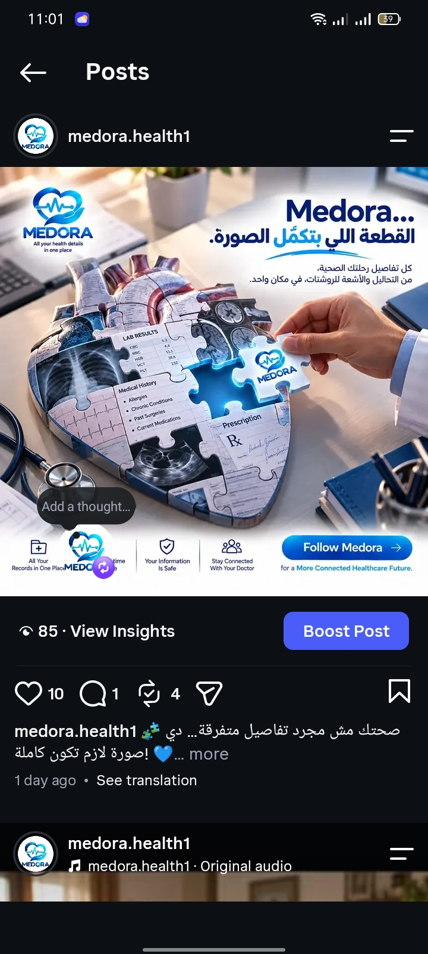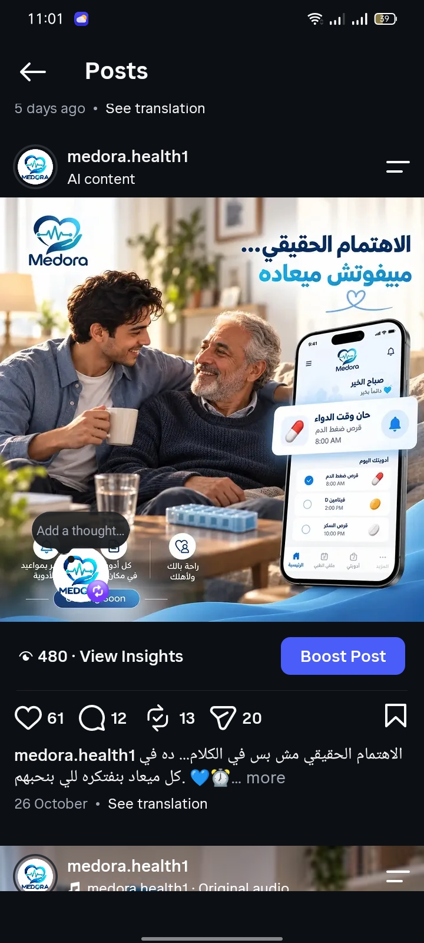

10.7 Brand kit
Element | Recommendation
Logo direction |  MEDORA Official Medora logo: caring hand + heart + ECG pulse, with the MEDORA wordmark. Use the supplied brand mark consistently on white, navy or approved gradient backgrounds.
Colors | Navy Blue — #003B73 (primary; logo, headings, key elements); Teal — #00B3A4 (secondary; buttons, active states, icons); Light Blue — #4CC3F1 (accent; highlights and graphics); Pale Blue — #E6F4FF (light surfaces and cards); White — #FFFFFF (main background).
Visual style | Calm, uncluttered UI mockups; realistic generic record cards; clear hierarchy, dates, sources, permissions and status labels.
Voice | Helpful, reassuring, non-clinical when describing software; explicit about prototype limits and AI review.
Typography | English: Poppins (Light, Regular, Medium, SemiBold, Bold). Arabic: Cairo (Light, Regular, Medium, SemiBold, Bold). Use SemiBold/Bold for headings and Regular for body text.
Gradients | Primary: Navy Blue #003B73 → Teal #00B3A4. Secondary: Light Blue #4CC3F1 → Teal #00B3A4.

10. Landing Page and Conversion Design

11.1 Recommended page structure and sample copy
القسم (Section) | النص المقترح / الوظيفة (Draft Copy / Job)
العنوان الرئيسي (Hero Headline) | رحلتك الطبية... منظمة في مكان واحد.
العنوان الفرعي (Subheadline) | اجمع تقارير التحاليل، والأشعة، والوصفات الطبية، ومهام المتابعة في جدول زمني واحد، وشارك السجلات التي تختارها مع الأطباء الذين تمنحهم صلاحية الوصول.
عرض المشكلة (Problem Block) | قد تكون سجلاتك الطبية المهمة موزعة بين الملفات الورقية، ورسائل المحادثات، ومواقع المعامل، والأجهزة المختلفة. تعمل Medora على استكشاف طريقة أكثر وضوحًا لتنظيم هذه السجلات والوصول إليها.
الدعوة الرئيسية لاتخاذ إجراء (Primary CTA) | انضم إلى تجربة النموذج الأولي لمنصة Medora / اطلب الانضمام إلى البرنامج التجريبي.
الدعوة الثانوية لاتخاذ إجراء (Secondary CTA) | للعيادات: ناقش معنا إمكانية المشاركة في تجربة المنصة.

11. Performance Marketing and Tracking

12.1 Campaign structure
Campaign | Objective | Audience / source | Creative / landing page | Success measure
Patient discovery | Learn which message creates qualified interest. | Broad adult audience within pilot geography, only where platform policies allow; no targeting based on inferred diagnoses. | Education/organization creative to patient prototype page. | Qualified opt-in leads, form completion, interview participation.
Clinic discovery | Recruit clinic interviews or demos. | Professional outreach and direct clinic list built lawfully. | Clinic workflow insight post plus clinic-specific form. | Qualified clinic conversations, booked demo rate.
Retargeting test | Re-engage consenting/eligible site visitors when technically and legally appropriate. | Only if platform policy, consent, and privacy/legal review support it; do not build health-condition audiences. | Product walkthrough or FAQ. | Return sessions and completed conversions; monitor complaints/opt-outs.

12.5 Dashboard KPIs and formulas
KPI | Formula | Use
CTR | CTA clicks / impressions x 100% | Compare creative hooks, not health outcomes.
Landing-page conversion rate | Valid opt-in forms / landing-page sessions x 100% | Assess offer, trust, page clarity, and form friction.
Qualified lead rate | Leads meeting defined criteria / all leads x 100% | Measure relevance of channel and message.
Demo booking rate | Clinic demos booked / qualified clinic leads x 100% | Assess B2B path.
Lead response SLA | Leads handled within internal target / valid leads x 100% | Evaluate automation reliability and team process.
Task completion rate | Successful usability tasks / attempted tasks x 100% | Assess product usability.
AI extraction field accuracy | Correct fields / fields evaluated x 100% | Evaluate admin extraction only; report by field/document type and include unknowns.
Reminder opt-out/error rate | Opt-outs or failed sends / reminder attempts x 100% | Monitor permission quality and unwanted messages.

12. Automation and AI Workflow


